Microsoft Excel Assessment

- Open up Microsoft Excel.
- Enter CTE INTRO into cell A1. Bold it and change the font size to 18.
- Enter your name and class period in cell A2. Bold and change the font size to 14.
- In cell A4, change the teacher’s name to your CTE Intro teacher’s name and bold it.
- In cell A6, enter Class Roster. Make it bold.
- Enter the column headings, beginning in cell A8. Change the font size to 10 and bold and center each of the column headings.
- Beginning in cell A9, enter the rest of the data shown below.

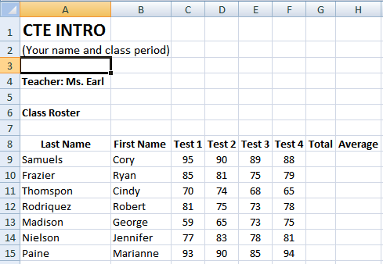

- Using AUTO SUM, total the number of points for each student in cells G9-G15.
- In cell H9, calculate the average for Cory Samuels. To get the average, divide the total score by 4. Use a formula. If you do the math, it won’t calculate the average for the other students.
- Use the fill handle to calculate the averages for the other students.
- Center the information in cells C9 – H15.
- Change the numbers in the Average column to round to 0 decimal places.
- Select the first name column. Hold down the CTRL button and select the averages column.
- Go to Insert and insert a column chart. Use the first one.
- Move your chart over under your spreadsheet.
- Make sure your chart is NOT selected and go into Print Preview. Make sure everything is going to fit on one page. If not, fix your margins or move your chart so that it does.
- Print.
- Save as (Your Name) Excel Assessment.

Congratulations! You are finished!

